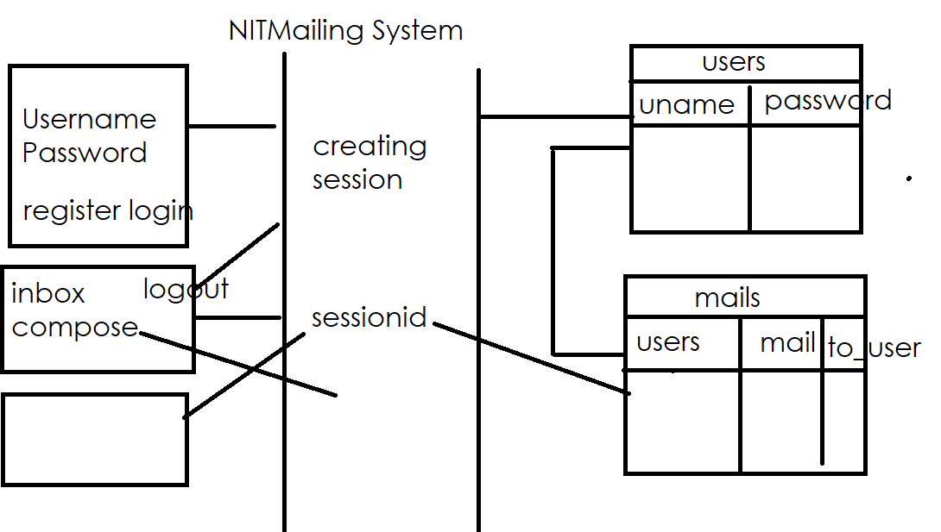

PS C:\Users\Satish Gupta> cd D:\Backup\Django9amMar
PS D:\Backup\Django9amMar> django-admin startproject project31
PS D:\Backup\Django9amMar> cd project31
PS D:\Backup\Django9amMar\project31> python manage.py startapp app
PS D:\Backup\Django9amMar\project31>

>>> from app.models import Users,Mails
>>> u1=Users(uname='naresh',password='n123')
>>> u1.save()
>>> u2=Users(uname='suresh',password='s123')
>>> u2.save()
>>>
>>> mail1=Mails(touser='suresh',content='Hello',fromuser=u1)
>>> mail1.save()
>>> mail2=Mails(touser='naresh',content='Bye',fromuser=u2)
>>> mail2.save()
>>> mail3=Mails(touser='naresh',content='python',fromuser=u2)
>>> mail3.save()
>>>
>>> u1.delete()
(2, {'app.Mails': 1, 'app.Users': 1})
>>>

Views.py
from django.shortcuts import render,redirect
from app.models import Users,Mails
# Create your views here.

def users_view(request):
if request.method=="GET":
response=render(request,"users.html")
return response
else:
uname=request.POST.get("uname")
pwd=request.POST.get("pwd")
b=request.POST.get("b")
if b=="register":
try:
Users.objects.create(uname=uname,password=pwd)
response=render(request,"users.html",context={'msg':'user created'})
return response
except:
response=render(request,"users.html",context={'msg':'user with this name exists'})
return response
else:
try:
user=Users.objects.get(uname=uname,password=pwd)
request.session['uname']=uname
response=render(request,"mails.html",context={'uname':uname})
return response
except:
response=render(request,"users.html",context={'msg':'invalid username or password'})
return response
def inbox_view(request):
uname=request.session['uname']
qs=Mails.objects.filter(touser=uname)
response=render(request,"inbox.html",context={'qs':qs})
return response
def logout_view(request):
del request.session['uname']
response=redirect('users')
return response
def compose_view(request):
if request.method=="GET":
response=render(request,"compose.html")
return response
else:
fromuser=request.session['uname']
touser=request.POST.get('touser')
content=request.POST.get('content')
user=Users.objects.get(uname=fromuser)
Mails.objects.create(touser=touser,content=content,fromuser=user)
response=redirect("inbox")
return response

urls.py

from django.contrib import admin
from django.urls import path
from app.views import users_view
from app.views import inbox_view,logout_view
from app.views import compose_view
urlpatterns = [
path('admin/', admin.site.urls),
path('users/',users_view,name='users'),
path('inbox/',inbox_view,name='inbox'),
path('logout/',logout_view),
path('compose/',compose_view),
]

Settings.py
INSTALLED_APPS = [
'django.contrib.admin',
'django.contrib.auth',
'django.contrib.contenttypes',
'django.contrib.sessions',
'django.contrib.messages',
'django.contrib.staticfiles',
'app'
]

SESSION_ENGINE='django.contrib.sessions.backends.db'

TEMPLATES = [
{
'BACKEND': 'django.template.backends.django.DjangoTemplates',
'DIRS': [BASE_DIR/"templates"],

compose.html
<!DOCTYPE html>
<html lang="en">
<head>
<meta charset="UTF-8">
<meta name="viewport" content="width=device-width, initial-scale=1.0">
<title>Document</title>
</head>
<body>
<form method="post">
{%csrf_token%}
<table border="2" width="100%">
<tr>
<td>Touser</td>
<td><input type=text name="touser"></td>
</tr>
<tr>
<td>Content</td>
<td><textarea name="content" rows="10" cols="40"></textarea></td>
</tr>
<tr>
<td><input type="submit" value="send"></td>
<td><input type="reset" value="clear"></td>
</tr>
</table>
</form>
</body>
</html>

Inbox.html
<!DOCTYPE html>
<html lang="en">
<head>
<meta charset="UTF-8">
<meta name="viewport" content="width=device-width, initial-scale=1.0">
<title>Document</title>
</head>
<body>
<table border="2" width="100%">
<tr>
<th>FromUser</th>
<th>Content</th>
</tr>
{%for mail in qs%}
<tr>
<td>{{mail.fromuser.uname}}</td>
<td>{{mail.content}}</td>
</tr>
{%endfor%}
</table>

</body>
</html>

Users.html
<!DOCTYPE html>
<html lang="en">
<head>
<meta charset="UTF-8">
<meta name="viewport" content="width=device-width, initial-scale=1.0">
<title>Document</title>
</head>
<body>
<form method="post">
{%csrf_token%}
<table border="2" width="100%">
<tr>
<td>UserName</td>
<td><input type=text name="uname"></td>
</tr>
<tr>
<td>Password</td>
<td><input type=password name="pwd"></td>
</tr>
<tr>
<td><input type="submit" value="login" name="b"></td>
<td><input type="submit" value="register" name="b"></td>
</tr>
</table>
</form>
<h2>{{msg}}</h2>
</body>
</html>

Mails.html
<!DOCTYPE html>
<html lang="en">
<head>
<meta charset="UTF-8">
<meta name="viewport" content="width=device-width, initial-scale=1.0">
<title>Document</title>
</head>
<body>
<h2>Hello,{{uname}}</h2>
<br><br>
<h2><a href="/inbox">inbox</a></h2>
<h2><a href="/compose">compose</a></h2>
<h2><a href="/logout">logout</a></h2>
</body>
</html>

Users.html
<!DOCTYPE html>
<html lang="en">
<head>
<meta charset="UTF-8">
<meta name="viewport" content="width=device-width, initial-scale=1.0">
<title>Document</title>
</head>
<body>
<form method="post">
{%csrf_token%}
<table border="2" width="100%">
<tr>
<td>UserName</td>
<td><input type=text name="uname"></td>
</tr>
<tr>
<td>Password</td>
<td><input type=password name="pwd"></td>
</tr>
<tr>
<td><input type="submit" value="login" name="b"></td>
<td><input type="submit" value="register" name="b"></td>
</tr>
</table>
</form>
<h2>{{msg}}</h2>
</body>
</html>

Authentication and Authorization

Django's built-in authentication system handles both authentication (verifying who a user is) and authorization (deciding what they can do). It is bundled in the django.contrib.auth module and works out of the box with the default project settings.

Core Components
- Users: The central model representing people interacting with your site. It includes standard fields like username, email, and password.
- Permissions: Binary flags (yes/no) used to determine if a user can perform specific tasks. Django automatically creates "add", "change", "delete", and "view" permissions for every model.
- Groups: A way to categorize users and apply permissions to multiple people at once.
- Password Hashing: Django never stores raw passwords; it uses strong hashing algorithms like PBKDF2 (default) or Argon2

